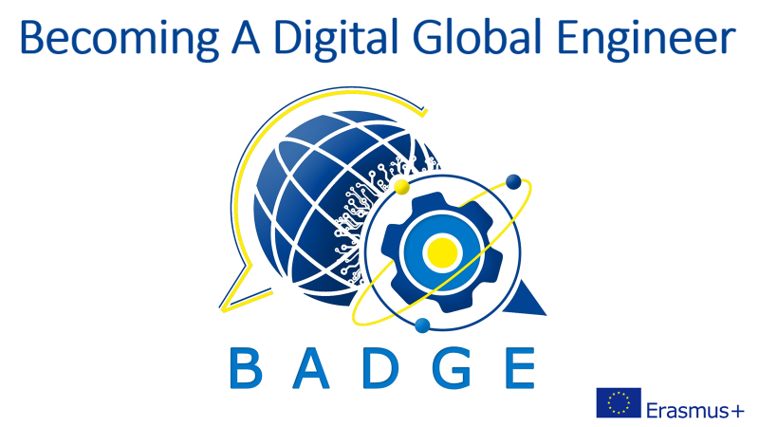

Intellectual Output 1

HEALTH & SAFETY AT WORKPLACE:

PANDEMIC

INTRODUCTION

From this unit you will learn: the story of the COVID-19 pandemic, how Bill Gates predicted the outbreak in 2015, how to stay safe.

DISCUSSION QUESTIONS

What is the difference between an epidemic and pandemic? How did the pandemic change affect your life and education? Did this experience have any advantages?
TEACHER’S INPUT
How does a coronavirus work?
Watch: https://www.youtube.com/watch?v=BtN-goy9VOY&t=131s

READING

The Story of COVID-19

On 11 March 2020 the World Health Organization finally declared a pandemic of COVID-19. However, one can easily assume that the disease was a pandemic well before this date. At the end of that year there were 83 million confirmed cases of infections all over the world with more than 1,800,000 deaths. And many say that such a course of events could have been easily predicted. In 2015 Bill Gates warned the world in a TED talk entitled “The Next Outbreak? We’re Not Ready”. In the spring of 2017 Bryan Walsh wrote a feature story for “TIME” magazine with the cover announcing “Warning: the world is not ready for another pandemic”. Over the past years there have been many articles claiming that a global pandemic of some new respiratory disease was only a matter of time. In 2019 the US Department of Health and Human Services organized a pandemic exercise called “Crimson Contagion” which actually did simulate a flu pandemic starting in China and spreading from there all over the world. According to that simulation 586,000 American citizens were going to die. In real life, in December 2020 there were more than 211,000 victims confirmed in the US.

Throughout history, the viruses, bacteria and parasite causing diseases have deprived of life more humans than any wars. The Black Death of the 14th century which killed about 200 million people. It is worth noting that the experts believe that COVID-19 is probably the same pathogen. The smallpox in the 20th century executed 300 million people and the infamous Spanish Flu of 1918 infected one in every three people on the planet. The mosquito-borne malaria still takes the toll of 500,000 people a year, not to mention HIV which has killed around 32 million so far. And the problem is not only that every single year new infectious diseases like SARS or Covid-19 break out but since 1980 the number of such outbreaks has more than tripled. One of the reasons for such an expansion of disease-carrying animals and insects is the climate change.

Pathogens are mass killers as they replicate themselves. When a virus infects a host, that host turns into a walking factory of the virus. We move around, interact with other human beings and spread the disease. The bacteria are self-replicating as well. That is why at the beginning of the 19th century before the proper sanitation, antibiotics and vaccines, the global life expectancy was only 29 years!
It is a well-known fact that COVID-19 emerged in Wuhan - a crowded Chinese city and spread to the rest of the world in a matter of months. As Bryan Walsh wrote in March 2020 in “TIME”: “Our response to it has been both hyper-modern – and practically medieval. Scientists around the world are using cutting-edge tools to rapidly sequence the genome of the coronavirus, pass along information about its virulence, and collaborate on possible countermeasures and vaccines, all far quicker than could have been done before. But when the virus arrived among us, our only effective response was to shut down society and turn off the assembly line of global capitalism. Minus the text alerts, the videoconferencing and the Netflix, what we were doing wasn’t that different from what our ancestors might have tried to halt an outbreak of the plague. The result has been chemotherapy for the global economy”.
Half a year later vaccines were ready along with numerous activists of the antivaccination movement. The WHO named this movement one of the world’s top 10 public-health threats. On 10 February 2021 the joint statement by UNICEF Executive Director Henrietta Fore and WHO Director-General Dr. Tedros Adhanom Ghebreyesus was issued.
“Of the 128 million vaccine doses administered so far, more than three quarters of those vaccinations are in just 10 countries that account for 60% of global GDP. As of today, almost 130 countries, with 2.5 billion people, are yet to administer a single dose. This self-defeating strategy will cost lives and livelihoods, give the virus further opportunity to mutate and evade vaccines and will undermine a global economic recovery.
Today, UNICEF and WHO – partners for more than 70 years – call on leaders to look beyond their borders and employ a vaccine strategy that can actually end the pandemic and limit variants. […] We need global leadership to scale up vaccine production and achieve vaccine equity. COVID-19 has shown that our fates are inextricably linked. Whether we win or lose, we will do so together.”
And finally the concise advice from the WHO how to stay safe:
If COVID-19 is spreading in your community, stay safe by taking some simple precautions, such as physical distancing, wearing a mask, keeping rooms well ventilated, avoiding crowds, cleaning your hands, and coughing into a bent elbow or tissue.
READING TASK: Recall 3 facts you learnt from the text.
VOCABULARY
Read the WHO precautions regarding Coronavirus and match the headings to the paragraphs:
- Maintain social distancing
- If you have fever, cough and difficulty breathing, seek medical care early
- Practice respiratory hygiene
- Avoid touching eyes, nose and mouth
- Stay informed and follow advice given by your healthcare provider
- Wash your hands frequently

WHO Basic protective measures against the new Coronavirus – 18 March 2020
Stay aware of the latest information on the COVID-19 outbreak, available on the WHO website and through your national and local public health authority. Most people who become infected experience mild illness and recover, but it can be more severe for others. Take care of your health and protect others by doing the following:
- …………………F………………………Regularly and thoroughly clean your hands with an alcohol-based hand rub or wash them with soap and water to kill viruses that may be on your hands.
- …………………A……………………….Maintain at least 1 metre (3 feet) distance between yourself and anyone who is coughing or sneezing. When someone coughs or sneezes they spray small liquid droplets from their nose or mouth which may contain virus. If you are too close, you can breathe in the droplets, including the COVID-19 virus if the person coughing has the disease.
- ……………………D……………………..Hands touch many surfaces and can pick up viruses. Once contaminated, hands can transfer the virus to your eyes, nose or mouth. From there, the virus can enter your body and can make you sick.
- ……………………C………………………Make sure you, and the people around you, follow good respiratory hygiene. This means covering your mouth and nose with your bent elbow or tissue when you cough or sneeze. Then dispose of the used tissue immediately. Droplets spread virus. By following good respiratory hygiene you protect the people around you from viruses such as cold, flu and COVID-19.
- ……………………B………………………Stay home if you feel unwell. If you have a fever, cough and difficulty breathing, seek medical attention and call in advance. Follow the directions of your local health authority as they will have the most up to date information on the situation in your area. Calling in advance will allow your health care provider to quickly direct you to the right health facility. This will also protect you and help prevent spread of viruses and other infections.
- ……………………E……………………….Stay informed on the latest developments about COVID-19. Follow advice given by your healthcare provider, your national and local public health authority or your employer on how to protect yourself and others from COVID-19. They will have the most up to date information on whether COVID-19 is spreading in your area. They are best placed to advise on what people in your area should be doing to protect themselves.

FURTHER PRACTICE
Can you interpret the WHO poster below?

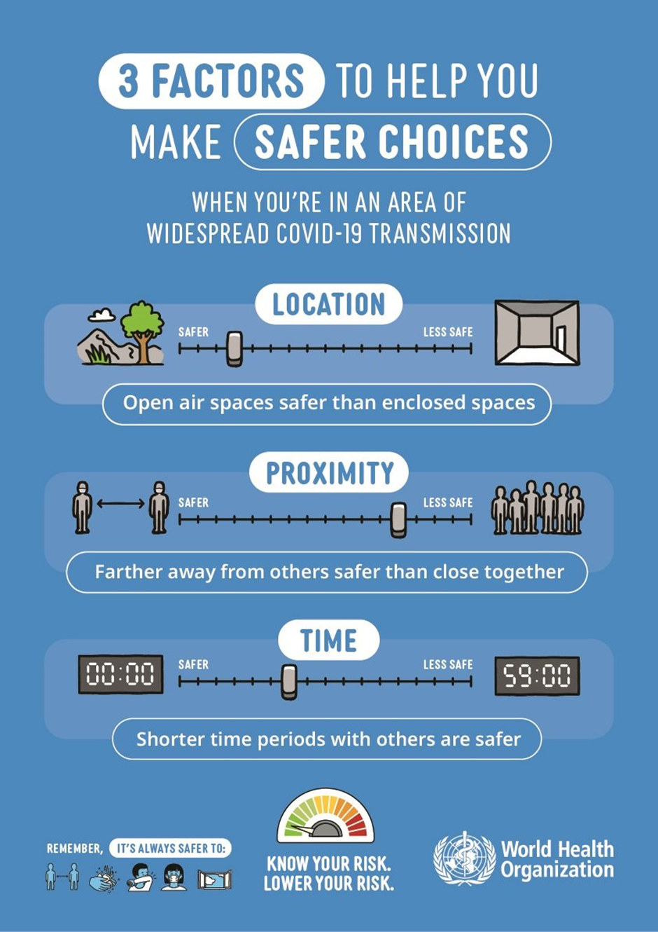
Watch Bill Gates: The next outbreak? We're not ready | TED Talk 2015
Answer the questions:
- What disaster were people afraid of in Gates’ childhood? How did they prepare to survive?
Nuclear war. A barrel in the basement filled with cans of food and water.
- What global danger should the humankind be afraid of now? What epidemics does he refer to?
An infectious virus. Ebola in 3 West African countries killed about 10,000 people.
- What was missing to successfully fight with Ebola?
There was no system. There should have been a group of epidemiologists always ready to go, immediate online reporting, a method of preparing numerous medical staff and volunteers, proper diagnostics, studies on treatment approaches, e.g. survivors blood plasma injections
- What conclusions should be drawn from the Ebola and Spanish Flu epidemics?
We should build a really good response system based on cell phones application to get and give information and monitor how the virus is spreading. We should use all the benefits of science and technology to make drugs and vaccines to fit for the pathogen. We need preparedness similar to getting prepared for war.
- What are the key pieces of preparedness?
Strong health systems in poor countries. A medical reserve corps with the expertise. Pairing the medical people with the military. Simulations of germ games, not war games. Advanced R&D on vaccines and diagnostics.

