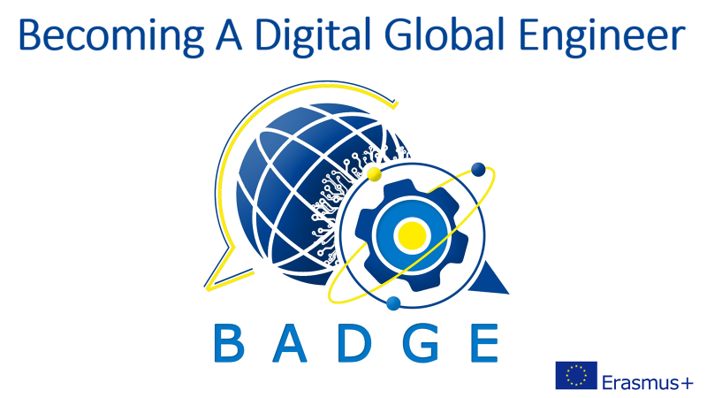

Intellectual Output 1

HEALTH & SAFETY AT WORKPLACE:
HANDLING STRESS

INTRODUCTION
From this unit you will learn: what causes stress at work and how to deal with it, and what life-work balance is.
DISCUSSION QUESTIONS
How do students cope with stress? Do you think the same remedies will work for you during your professional career?
READING
Complete the gaps A-O with the missing phrases 1-15:
1.boosts energy and brain power, 2.mental health, 3.be delegated, 4.life-work balance, 5.establishing boundaries, 6.mindfulness, 7.high blood pressure and heart diseases, 8.available 24/7, 9.work-related stressors, 10.ready-to-eat meals, 11.a dead-end job, 12.challenging and meaningful, 13.alcohol and other stimulants, 14.time-management, 15.going offline
It is perfectly OK to work hard but you have to be really careful if making a professional career starts happening at the expense of your private life, relationships and even health. Maintaining the proper A. …… is one of the challenges you will have to face on daily basis until the day you retire.
The most common B. ……. are connected with being overworked and underpaid, with managers from hell, with strict deadlines and unclear responsibilities, with bullying and mobbing. Frustration might also result from holding C. …….., from few opportunities for growth and development and from the lack of social support.
The problem is that usually stressors take a toll on your well-being after you leave the company’s premises. The easiest way to relax might mean cheering yourself up with junk food, cigarettes, D. ……... An unhealthy work environment makes you short-tempered, unable to concentrate and to enjoy the prime time with you family and friends. Chronic stress, which is building up for months and years, may lead to serious health conditions, such as a weakened immune system, anxiety, insomnia, depression, obesity, E. …..
It is a vital issue to develop efficient ways to make the tension fall. Work-out is a great solution. Any exercise, especially performed outdoors, lowers the stress level and improves your mood, F. ……, raises the endorphins level, clears your mind and makes your body stronger. Yoga is highly recommended as it combines physical and mental exercise. Another idea is making time for hobbies and favourite leisure activities. It might be reading, playing board games with your family, going to concerts or for long walks with a dog.
What experts strongly advise is G. ……. between work and “real life”, so called work-life balance. Especially nowadays in the digital world and the lockdown home offices it is common to feel pressure of being H. …….. That is why it is crucial to get disconnected from time to time. Switching off your phone or I. ……. is critical in order to avoid burnout. Also do not waste your holiday time – enjoy it as much as possible, don’t engage in anything connected with your professional responsibilities and stop thinking about work at all. You need to recharge your batteries.
Good quality sleep and food are also important for effective stress management. Make sure you do not work in your bedroom. Pay attention to regular sleep routine. Cook yourself, avoid J…… which you heat in the microwave. Obey the rules of decent nutrition.
Try to learn meditation techniques, breathing exercises and K. ……. Originally used as a therapeutic technique, today it is used to describe a way of life focusing your awareness on the present moment, acknowledging and accepting your feelings, thoughts and bodily sensations.
If the above methods do not work, talk to your supervisors as your low productivity and poor concentration obviously affect your general performance. If you feel overworked, clarify what your duties are, maybe some of those might L. …… to other employees. If quite the opposite, you feel stressed because you do not advance in your work, ask for a possibility to attend some training, obtain additional skills, change the department. Ask your boss to assign you a more M. ……. task. In general, try to get necessary support from your managers and colleagues. Maybe there is some counselling available, some stress management resources.
If you feel overwhelmed with too much work to do and too little time, try to improve your N. ……. techniques. There are many mobile phone applications that will help you plan your activities and execute the tasks results. Use the online calendars to coordinate the project timeline.
And last but not least, if the level of stress is too high, do not be afraid to admit a problem to your family and friends. Accept help from the people you trust. If needed, refer to a O. ……. specialist. Set up a meeting with a psychologist, a psychotherapist or a psychiatrist. React!
FURTHER PRACTICE
Andy Puddicombe: All it takes is 10 mindful minutes | TED Talk
Having watched the talk, put the paragraphs A-G in the proper order 1-7.
A. We live in an incredibly busy world. The pace of life is often frantic, our minds are always busy, and we're always doing something. When did you last take any time to do nothing? Just 10 minutes, undisturbed? No emailing, texting, no Internet, no TV, no chatting, no eating, no reading. Not even sitting there reminiscing about the past or planning for the future. We don't take any time out to look after our minds. In fact, we spend more time looking after our cars, our clothes and our hair. The result, of course, is that we get stressed. And the sad fact is that we are so distracted that we're no longer present in the world in which we live. We miss out on the things that are most important to us.
B. I think the present moment is so underrated. It sounds so ordinary, and yet we spend so little time in the present moment that it's anything but ordinary. There was a research paper that came out of Harvard that said on average, our minds are lost in thought almost 47 percent of the time. At the same time, this sort of constant mind-wandering is also a direct cause of unhappiness. There's a positive, practical, achievable, scientifically proven technique which allows our mind to be more healthy, to be more mindful and less distracted.

C. I was about 11 when I went along to my first meditation class. And trust me, it had all the stereotypes that you can imagine, the sitting cross-legged on the floor, the incense, the herbal tea, the vegetarians. Like a lot of people, I assumed that it was just an aspirin for the mind. You get stressed, you do some meditation.
D. And the beauty of it is that even though it need only take about 10 minutes a day, it impacts our entire life. But we need to know how to do it. We need an exercise. We need a framework to learn how to be more mindful. That's essentially what meditation is. It's more about stepping back, sort of seeing the thought clearly, witnessing it coming and going, emotions coming and going without judgment, but with a relaxed, focused mind.
E. We all deal with stress in different ways. Some people will bury themselves in work, grateful for the distraction. Others will turn to their friends, their family, looking for support. Some people hit the bottle, start taking medication. My own way of dealing with it was to become a monk. So I quit my degree, I headed off to the Himalayas, I became a monk, and I started studying meditation. It gave me a greater appreciation, an understanding for the present moment.
F. I was about 20 when a number of things happened in my life in quite quick succession, really serious things which just flipped my life upside down and all of a sudden I was inundated with thoughts, inundated with difficult emotions that I didn't know how to cope with.
G. Meditation offers the opportunity, the potential to step back and to get a different perspective, to see that things aren't always as they appear. We can't change every little thing that happens to us in life, but we can change the way that we experience it. That's the potential of meditation, of mindfulness. You don't have to burn any incense, and you definitely don't have to sit on the floor. All you need to do is to take 10 minutes out a day to step back, to familiarize yourself with the present moment so that you get to experience a greater sense of focus, calm and clarity in your life.

