Intellectual Output 1

HEALTH & SAFETY AT WORKPLACE:
ELECTRICITY

INTRODUCTION
From this unit you will learn: why electricity might be dangerous, what injuries it causes and how to help a person who suffered from a shock.
DISCUSSION QUESTIONS
Do you know what a socket, a plug and a switch are? What does it mean that a material is a conductor or an insulator? Do you know how to help a person who was electrocuted?
READING
Be a conscious power-user!
PARA 1.Before using any electrical appliance it is worth checking if you are safe. While using a portable device, check the extension cable. The equipment relies for its safety upon being connected to earth via the plug, so examine it thoroughly. The ends of flexible cables should always have the outer sheath of the cable firmly clamped to stop the wires (particularly the earth) pulling out of the terminals. Make sure that the socket outlet is not overloaded by use of adapters.
PARA 2.Fixed electrical equipment should have a clearly identified switch to cut off power in an emergency. It is also important to check the fuse as it protects the device from over current. It is designed to ‘blow’ and cut off the electricity when the current exceeds its rated capacity. Ensure the correct fuse is used for the appliance. Workplaces generally have power nominally supplied at 230 volt (single phase) and 400 volt (3 phase). If equipment operating at 230 volts or higher is used, a residual current device should be used to provide additional safety.
PARA 3.RCD’s are supplementary protection devices which detect faults in the electrical system and rapidly switch off the supply. By enabling the rapid disconnection of the electricity supply when an electrical shock takes place, they can limit the injury. RCD's are mandatory on all circuits supplying portable equipment. They are also compulsory where the hazard of electricity is exacerbated by the proximity of water. The best place for an RCD is built into the main switchboard or the socket outlet. It is not an exaggeration to ask the maintenance staff if an RDC is installed and whether it’s been done by a competent professional. Regular inspections of the power supply is a key factor, too.
PARA 4.The main danger electricity poses to humans is contact with live parts which causes shock and burns. As water is a good conductor, the risk of injury is greater in wet or damp conditions. The severity of the effect electric shock has on the human body depends on the voltage, the length of time electricity flows through the body and the path the current takes inside it. An alternating current is often more harmful than a direct current because it causes muscle spasms that make it harder to drop the source of electricity. That is why the key prerogative is to stop the electricity flow through the human body.
PARA 5.An electric shock may lead to loss of consciousness, muscle spasms, numbness or tingling, breathing problems, headache, problems with vision or hearing, burns, seizures, irregular heartbeat. Another serious risk is the compartment syndrome. It is a serious condition that occurs when there’s a large amount of pressure inside a muscle compartment which can cut off blood flow. This can result in loss of oxygen going to the tissues (ischemia) and cellular death (necrosis).
PARA 6.Remember! The human body is a good conductor of electricity. If you touch a person while they are in contact with the electrical source, the electricity will also flow through your body causing electrical shock to you too. If the victim is not able to remove themselves from the electrical source, firstly you must disconnect the source of the electricity. However, if the RCD did not work or if the electrical source cannot be readily and safely turned off, use a non-conducting object to separate the victim from the electrical source. If you look around, there are plenty of poor conductors of electricity, offering a lot of resistance that prevents the current from flowing through them. The most common insulators are: wood, plastic, paper, rubber, glass, Teflon, fiberglass. Hence it is not a challenge to find a useful tool: a wooden stick, a plastic box, anything! Be resourceful !
PARA 7.Electrical power is dangerous not only with regard to individual human beings. It could be also the source of ignition in a potentially flammable or explosive atmosphere, e.g. in a spray paint booth. In such cases electricity poses much more harmful danger as it may cause fire or explosions with much more devastating consequences – damage to the building and everybody residing in it.
An RCD in a switchboard
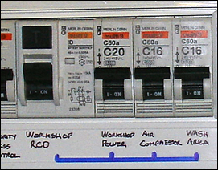
Examples of Residual Circuit Devices (RCDs)
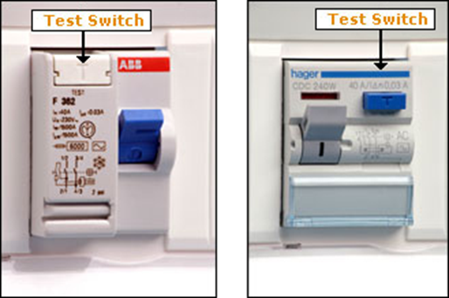

READING PRACTICE

Find in the text the words that mean the following:

PARA1
Cover, casing -
Clasped, squeezed -
PARA 2
Safety valve -
PARA 3
Fast -
Worsened -
Closeness, nearness -
PARA 4
A material/object that allows the flow of current -
PARA 5
Sudden uncontrolled electrical disturbances in the brain -
PARA 6
Substances/materials that resist electricity -
Inventive -
PARA 7
The action of setting something on fire or starting to burn -
Easily set on fire, burnable -

VOCABULARY PRACTICE
Complete the text about FIRST AID with the following words:

SWITCH, CARDIOPULMONARY, CURRENT, ELECTROCUTED, RUNNING,
PLUG, CONSCIOUSNESS, RECOVERY, CONSCIOUS, SUBSIDED

How to help a person who's been…..?
Before touching the victim always turn off the source of the ….either by pulling the ……out or by turning power off by a …… or a circuit breaker.
There are three possible scenarios to consider depending on the condition of the victim.
- The victim is …... Check their skin for any signs of burns at the entry and exit points of the electrical current. Wet the burns under …..water for at least five minutes or until the pain has …… Call the emergency services in all cases as an electrical current may have caused internal injuries.
- The victim has lost …… but is breathing normally. Put them in the …… position. Alert the emergency services, apply cold compresses to the burns until medical help arrives.
- The victim has lost consciousness and is not breathing. Alert the emergency services, start ………. resuscitation.

FURTHER PRACTICE
RECOVERY POSITION
If a person is unconscious but is breathing and has no other life-threatening conditions, they should be placed in the recovery position to keep their airway clear and open. It also ensures that any vomit or fluid won't cause them to choke.
How to do it? Watch the video:
http://youtube.com/watch?v=TRQePNmR66w
Put the sentences A-I in the proper order 1-9:
A.Carefully roll the person onto their side by pulling on the bent knee.
B. With the person lying on their back, kneel on the floor at their side.
C. Make sure their bent leg is at a right angle.
D. Extend the arm nearest you at a right angle to their body with their palm facing up.
E.Use your free hand to bend the person's knee farthest from you to a right angle.
F.Open their airway by gently tilting their head back and lifting their chin, and check that nothing is blocking their airway.
G.Take their other arm and fold it so the back of their hand rests on the cheek closest to you, and hold it in place.
H.Their bent arm should be supporting the head, and their extended arm will stop you rolling them too far.
I.Stay with the person and monitor their condition until help arrives.

