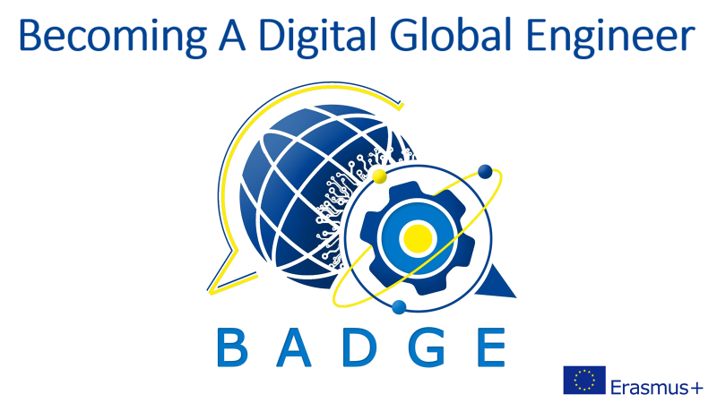

Intellectual Output 7
Instructions for the serious game

Instruction for teachers and trainers

This serious game is meant as an introduction to intercultural classes. It’s NOT meant to stand alone, but to open minds and be able to better understand theories and classes afterwards.

The serious game consists of three stories: the student can choose which character he/she wants to play or you can decide which story to start with. He/she can go back to the beginning to choose another answer as the first time to see what happens.

In the game there are 3 main stories. The three characters don’t belong to a specific culture, because we want to create awareness and empathy, not stereotypes.
For the moment, each story is available in a different language, but the aim is to have a complete set of stories in at least the three languages we have now ( English, Spanish and German), but if possible more languages.

Obviously the idea is not to get into stereotypes, but to show the players that we do not all act in the same way because we are from different cultures. Also, our actions don’t depend just on our culture but on the construction of the "I" that each one forges throughout his life.

The characters will be immersed in 3 different moments while living abroad. These moments are: exchange semester, internship, first job.

The videos have been produced through Artificial Intelligence using the Synthesia platform. The videos are all available on our Youtube channel BADGE EU
(https://www.youtube.com/channel/UCXOfzBfJiUyQ93CJ38Hlf3A?app=desktop) and have then been embedded in a genially escape game. The genially game can be duplicated. Feel free to develop more situations and either create your own game or send it to us and we’ll incorporate it in our game.
The scripts of the stories are all available on the website in word and pdf form.

A lot of situations have been taken from the catalogue of critical incidents, collected from alumni of KTH in Sweden. You find this catalogue on the BADGE website along with the game. We suggest you download the catalogue, because there are open questions to be discussed before or after playing the game and you’ll also find a lot more situations than in the game.

Other situations have been produced by the students from Volgatech in Russia, IMT Mines Albi, INSA and ISEA Supaéro in France, as well as students from our partners in Bjelovar in Croatia and Athens in Greece and a thesis student in Lithuania. They are based on their experiences or stories they heard.

The scripts of the game are also available on the website, they include only what the characters in the AI films say, not the choices in the game.

We suggest you try the game yourself first before letting your students play to get an overview over the situations.

We’ll be happy to read any comment you might want to make about the game. There is a comment box on the summary page and at the end of each story. You and your students can leave a comment there or write us an email at: badge.eu@gmail.com

Have fun

Katja Auffret

“All our actions and decisions are connected and the possibilities of interrelationships are unpredictable”

Author
Katja Auffret
Lecturer in German, Department of Foreign Languages,
IMT Mines Albi, France

Co-authors
Dr. Tatiana Golikova
Associate Professor, Department of Foreign Languages and Linguistics
Volga State University of Technology, Russia

Marlon Patiño
Lecturer in Spanish, Department of Foreign Languages,
IMT Mines Albi, France

Vilma Sukacke
PhD Student
KTU, Lithuania

Students from Volgatech, Russia, IMT Mines Albi, INSA Toulouse and ISAE Supaéro, France, Bjelovar, Croatia and NTUA, Greece

