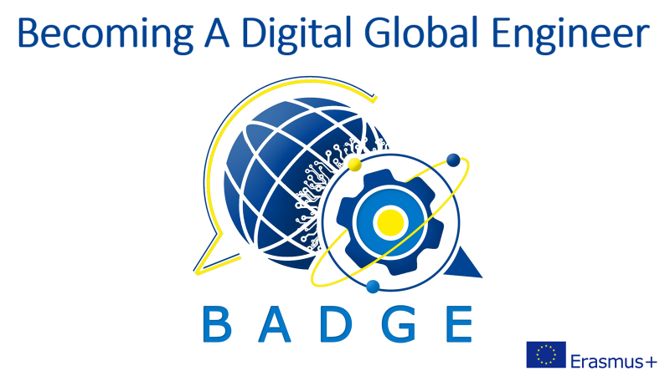

Intellectual Output 7
E-guide
Global Conversations
Volume 1

GLOBAL CONVERSATIONS FOR ENGINEERING STUDENTS: A CROSS-CULTURAL E-COMMUNICATION JOINT PROGRAM

E-Guidebook with learning activities focusing on new and innovative cross-cultural communication practices for engineering schools and technical universities
Contents Volume 1
Preface 5
Part 1 Factors and barriers involved in a cross-cultural e-communication joint program for international students 7
Part 2 Overview of the Global Conversations for Engineering Students 11
Illustration 1: Stages of the Global Conversations program 13
Part 3 Class preparation and implementation of the program 19
Illustration 2: Extract of the padlet with Internet tools 20
Illustration 3: WBS Learnspace 3D 21
Illustration 4: Word-cloud from French students about Russia 24
Illustration 5: Word cloud from Russian students about France 25
Illustration 6 : Template for a lesson plan 28
Illustration 8: Student presentation 31
Illustration 9: First videoconferencing sessions Volgatech, IMT Mines Albi 32
Illustration 10: Videoconferencing session Croatia - Russia 34
Illustration 11: Presentation of VolgaTech, Russia, by Russian students 34
Illustration 12: Presentation of Isae-Supaéro, France, by French students 35
Illustration 13: Students’ presentations about HE 35
Illustration 14: Students’ presentations about values 37
Illustration 15: First dilemmas imagined by students 38
Illustration 16: social problems presented by students 38
Illustration 17: Social issues in France presented by students 39
Part 4 Professional ethical dilemmas in FL classes 41
Illustration 19: Template for the activity plan 46
Illustration 20: Dealing with a dilemma 51
Part 5 Review of the findings and students’ feedback 57
Illustration 21: Students’ feedback 61
Illustration 22: Students’ feedback 62
Illustration 23: Students’ feedback 63
Illustration 24: Students’ feedback 63
Illustration 25: Students’ feedback 64
Illustration 26: Students’ micro group video conferences (IMT Mines Albi, INSA Toulouse and VolgaTech students (micro-groups and individual sessions) 2019-2020 66
Illustration 27: Students’ micro group video conferences (Russia and Croatia) 67
Illustration 28: Students’ micro group video conferences (Russia, France, Greece and Croatia) 67
Conclusion 68
Acknowledgements 71
References 72

Author
Dr. Tatiana Golikova
Associate Professor, Department of Foreign Languages and Linguistics
Volga State University of Technology, Russia
Co-author
Katja Auffret
Lecturer in German, Department of Foreign Languages,
IMT Mines Albi, France

Preface
A continually expanding trend toward international collaboration in academic, professional, and personal spheres due to globalisation and integration is paramount. We see the need to integrate into the global community is becoming a more and more valuable skill set for our prospective students and specialists. Thus, for educators, there is an urgent need to discover ways which develop in our students, a Global competence in civil and cross-cultural communication. This competence can be defined as “the capacity to examine local, global and intercultural issues, to understand and appreciate the perspectives and worldviews of others, to engage in open, appropriate and effective interactions with people from different cultures, and to act for collective well-being and sustainable development”. (Source : OECD).
It is a well-known fact that we are currently living in a digital age and that digital education has become a fact of life that is integrated into the reality our students face everyday.. The Pandemic (COVID-19) has intensified the process of introducing online courses into the system of higher education. Teachers had to deal with making an individual trajectory for foreign language learners, updating programs, examining the content of new educational material, searching for new teaching methods, and techniques when conducting distance learning online or via hybrid modality.
Hence in order to communicate globally our students need to upgrade their e-communication skills in foreign languages (FL). As part of the BADGE project (you can learn more here: https://www.thebadgeproject.eu/) University FL teachers need to not only help increase their students’ language proficiency but also increase their competency in cross-cultural communication skill areas.
In this guidebook we propose a cross-cultural e-communication program for prospective engineers. The aim of the program is to develop their readiness for cross-cultural communication with international partners in a foreign language in order to solve problems of interpersonal and cross-cultural interaction, including in the sphere of their own professional activity.
The guidebook is intended for educators who would like to develop their students’ synchronous and asynchronous e-communication while teaching a foreign language through purposefully organized cross-cultural partnership between collaborating universities. This online interaction can be integrated into the language courses or into intercultural communication/global competence courses.
We will share the specificities of the teaching methods​ of​ organizing cross-cultural online communication for engineering students and their international partners. We will also address the stages of implementing the program and the topics for discussion.

Part 1 Factors and barriers involved in a cross-cultural e-communication joint program for international students

Cross-cultural communication and collaboration networks continue to expand past the classroom boundaries. The increasing popularity of hybrid and online learning demands FL teachers to identify and apply the most effective methods and teaching techniques to develop their students’ efficient FL skills along with their digital skills. By the same token, the university teachers adjust to the needs crucial for prospective engineering graduates thus to develop cross-cultural business e-communication skills currently being at the core of their professional global communication.
We consider that one of the effective means that optimizes students' foreign language skills is the organization of cross-cultural e-communication including asynchronous and synchronous videoconferencing sessions between engineering students from different countries. As part of the BADGE project implemented (Erasmus+Strategic Partnership KA 203) the co-organisers Katja Auffret (IMT) and Tatiana Golikova (VolgaTech) have carried out a joint cross-cultural e-communication program “Global Conversations for Engineering Students” since 2019. Over the previous 3 years more than 220 students from VolgaTech (Russia), IMT Mines Albi University (France); Bjelovar University of Applied Sciences (Croatia) and National Technical University of Athens (Greece) have participated in the program.
This program was developed on the basis of the accumulated experience of the author of this e-guide (T. Golikova), who has been integrating a specific online cross-cultural English training program called “Bridges to International Education: Global Conversations” since 2012 and developed the teaching methods of online cross-cultural communication for university students and their international partners. (Cunningham, A., & Golikova, T. (2022), Golikova, T. (2016).”
The aim of the teaching methods of organizing online cross-cultural communication for prospective engineers and their international partners is to form their readiness for online intercultural communication to solve problems of interpersonal and intercultural interaction, including in the sphere of professional activity. T. Golikova argues that the principles of forming future engineers' readiness for online intercultural communication are the unity of diagnostics and self-diagnostics, efficiency, tolerance, dialogicality, co-operation, and openness.
Thus foreign language (FL) teachers willing to implement the program with their students should bear in mind the following factors (organizational and pedagogical conditions) that are meaningful in the overall effectiveness of the program:
1. professional readiness of the teachers (co-organizers) to prepare and implement cross-cultural communication programs for their students. It is crucial to view the purpose of the cross-cultural exchange in the same light to have a similar level of investment from both sides to meet professional and educational goals for both cohorts to be ready to step in at any stage of the program implementation to help your/ your partner’s students in case they are confronted with a personal/technical problem;
2. implementation of the trinity of educational objectives teaching students (academic knowledge-based, values-based, and cognitive- based) that are relevant in their prospective communication with their foreign partners. These different categories of objectives focus on developing different types of thinking and a new depth of understanding regarding students own values and the values of others in the hopes of directing the students into reflection about their own personal and professional self-development;
3. learning the teaching methods of online cross-cultural communication involved in the program (see the flowchart below);
4. experience in international cooperation with foreign colleagues that is crucial for the co-organizers (including their teaching and living abroad). This sort of experience helps immensely in terms of understanding your partner students’ mentality since it gives you some idea about what kind of difficulties may come up in cross-cultural interactions and potential ways to overcome the barriers.
If you do not have cross-cultural experience, it may be advisable to consult with someone who does. This will give you an advantage when trying to trouble-shoot for your own students and will give you better insight in structuring the interactions and even choosing material and topics that will really resonate with both your students and those from another culture;
5. Readiness of the students to perform cross-cultural communication in a FL. The students need special in class training in cross-cultural communication including discussion of the suggested topics to develop their FL and e-communication skills as well as a good working knowledge of the topics regardless of their language as part of their FL syllabus before videoconferencing sessions with their foreign partners;
6. Discussion of professional ethical dilemmas during FL classes using the methods developed by T. Golikova (see part 4);
7. Civic responsibility of the participants. The students should be fully aware of their responsibility as a representative of their university and understand that by participating in such programs they immediately represent not just themselves but their faculty, university, culture and country. Thus they can form a stereotype about their country and its people, especially if their partners have never communicated with a citizen of their country.
This principle can be omitted if you choose Round 1 of the suggested program or prefer to apply a different method of dilemma discussion (Appendix 2.1)
The prospective barriers that the participants might be faced with can be grouped into personal or psychological issues. We have identified:
Prior to video-conferencing sessions during your in-class preparation and analyzing your students' pre-survey documents (Appendices 1.1-1.3) you need to identify those personality traits, fear or bias when interacting with foreigners in order to assist your students if need be dealing with them.
They should be addressed individually and they can occur at any stage of the program’s implementation. E.g.: the co-organisers had to switch partners at times though based on our experience it was only once at the beginning of the Covid pandemic due to one of the partner’s psychological issues. You will also learn much more about the major barriers analyzing your students’ feedback from post-surveys (part 5).
If you consider this program as part of an obligatory assignment for all your students on the course, then you may have to overcome a barrier connected with low motivation before they join the program The best way to deal with this potential barrier is to give clear expectations ahead of time and solve this problem individually including a choice of partners /choice of culture (if available)/ choice of extra topics for their discussion.
The next quite obvious barrier is participants’ FL proficiency and of course the best way to address it is to develop your students’ language level during your classes and/or to let them work in micro-groups on both sides during their video conferencing sessions for a student whose level is lower than intermediate to be paired up with a more FL advanced student.
The final set of barriers is connected with technical issues, scheduling or time-zone differences.
Our experiences have also proven that all the above-mentioned obstacles can be successfully surmounted. This cross-cultural e-communication program gives the positive benefit of evaluating our students' own perceptions and stereotypes of other cultures. The students compare their views with someone from another culture who may think differently about important social or professional ethical dilemmas.
In the next part we will go into details about the structure of the program.

Part 2 Overview of the Global Conversations for Engineering Students
To organise a cross-cultural e-communication joint program for engineering students, we suggest using the following stages of the program. Later we will provide more explanation of each stage.
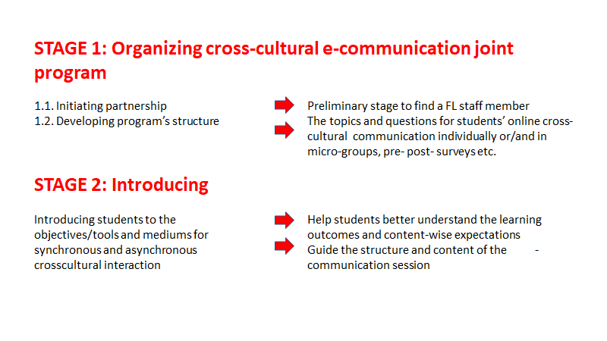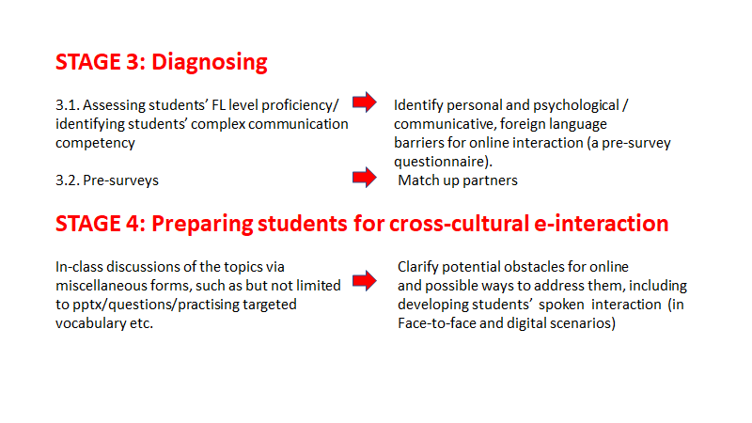

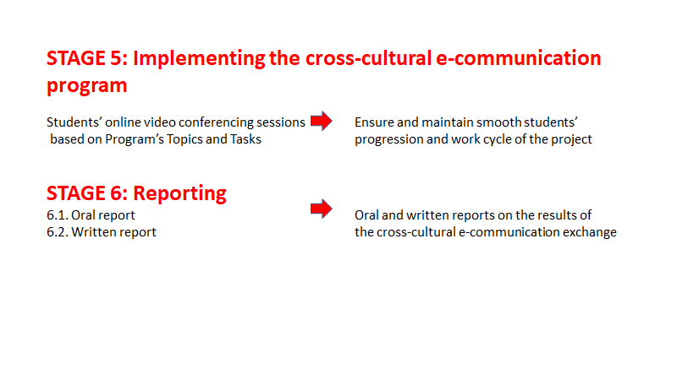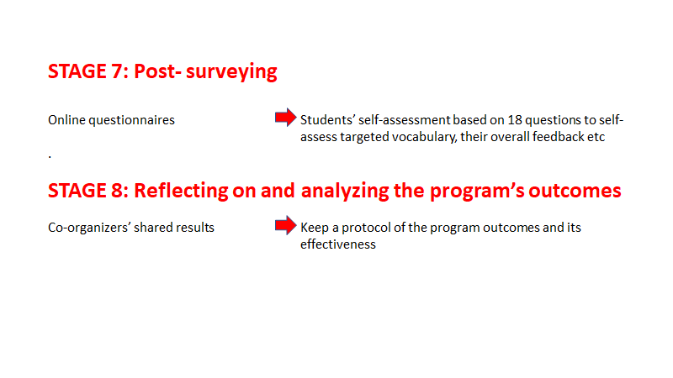Illustration 1: Stages of the Global Conversations program
We believe it is not that easy to organise purposeful cross-cultural communication to develop global competence, e-communication skills and achieve the course objectives for both of the classes (or more than two as we have also had 4 cohorts of students from 4 universities and countries) involved simultaneously. Such programs remain the exception rather than the rule. In our case our practical courses of English and German including the Global Conversations e-communication program for engineering students focus primarily on students mastering their FL language skills, developing their readiness for cross-cultural e-communication, providing them with the opportunity to prepare for e-communication during FL classes at a university and to practice their skills on a one-on-one basis with their international partners. Of course, a simple version of cross-cultural e-communication could be achieved by just setting up meetings between the students and letting them talk about whatever they felt like discussing. But then the higher-level course objectives will not be achieved.
Now let’s explore more specific aspects about the characteristics of each stage for you to consider.
Stage 1 is crucial for the success of the whole program namely initiating partnership between the faculty members involved. We place special stress on cross-cultural e-communication, not only between international students but also between the educators - the organisers of the program, serving as representatives of different cultures and countries. It facilitates their professional development as it gives a unique opportunity to learn from each other.
If you plan to organise a similar event for your students then you should make sure that both co-organizers are viewing the purpose of the cross-cultural exchange in the same light and that there is a similar level of investment from both sides. Hopefully your common goals will be fostered by continued collaboration implementing the program with future prospects to alter the program substantially according to your mutual objectives. Otherwise it will be only an instrumental perspective as something that could simply add interest to your FL course. We guess that it is extremely important to develop genuine partnership with a co-organizer to entrust your students to his/her influence, understanding, and reliability.
This will keep the course partnership moving forward for the full potential of the e-interaction to be realised.
- Establishing a partnership for online intercultural communication between international students, it is advised to choose engineering students from similar departments. Hence it will be more productive for them to compare not just general engineering issues as part of the assignment but to be more specific addressing professional values and scientific interests contrasting their educational background. However, in our experience, mixing students from different departments has several advantages. It encourages interesting and rhetorical consciousness, raising discussion among members who come from different parts of the technical universities.
- During this stage the co-organizers define the topics (Round 1, 2 or 3), select their content, forms, methods, teaching techniques of in-class preparation of the students and organization of their independent work, including the choice of platforms for both synchronous and asynchronous e-communication for international partners.
The main topics that we propose for discussion include "Cultural Differences and Stereotypes," "Educational Systems, Professional and Personal Values, “Professional Ethical Dilemmas” and "Growing Social Problems”. In the appendices (Volume 2) we provide three variations of the topics that we use depending on our objectives. You can choose one of the scenarios and/or alter it if need be. Our only reservation is that designing topics you should have similar tasks for both cohorts tailored to fit both courses. This way, the students feel like they are on the same page as their interlocutors and not like they are at cross-purposes.
At Stage 2 the co-organizers discuss the logistics of the GC program with their students introducing its purpose, topics and tasks of cross-cultural e-communication with foreign partners. They coordinate and adjust all the aspects taking into consideration the purpose and objectives of the FL courses where this e-communication program will be intertwined. Next the co-organizers are expected to have initial videoconferencing sessions with their partner’s cohorts of prospective participants. We propose different options of organizing them.
If the number of the students is less than 10 participants you might like to get acquainted with each foreign partner online individually with the purpose of examining his/her communicative and FL linguistic characteristics and his/her knowledge of a foreign language in order to identify potential barriers and to find a better match for each student. Otherwise you can hold video conferencing sessions to introduce the participants of the program (full group meeting) and its co-organizers simultaneously. If your students’ schedules are busy or due to widely-varying time zones it is not possible to organise a full group online meeting then you can organise individual sessions for each cohort for the co-organizers to introduce the program, their university and students before they start to communicate on a one on one basis. The platforms of videoconferencing meetings may vary greatly. Let the students choose them on their own.
During Stage 3 the co-organizers clarify some of the problematic issues (technical, communicative (personal), and linguistic ones) that their students might have during the program’s implementation. Both sets of students are given the same pre-surveys either from Round 1,2 or 3 via Google forms (see appendices 1.1-1.3 in Volume 2). By analyzing the pre-survey findings and interviews (if applicable) with the participants in class and online (via individual sessions mentioned above) you can also pair up in a timely and more efficient manner individual students or micro-groups to communicate with their foreign partners.
The program is targeted at engineering students whose level is B1 (minimum) of their FL proficiency. But we have had quite successful cases when some of the highly motivated students with lower language proficiency were part of a micro group interacting with international partners, showing better FL results after the course. It is up to each FL teacher to choose any online/in person assessment for their students. At some universities students need to pass obligatory international FL exams to enter it. In this case, the teachers don’t need to organise any special FL assessment before the program.

The student training process for this cross-cultural e-communication program is performed during stage 4. Part 3 of this e-guidebook deals with the specificities of how to integrate this educational training into FL classes. It includes but is not limited to preliminary discussion of the proposed topics preparing presentations, mastering speech clichés for public speaking and target vocabulary, creating professional ethical dilemmas and discussing them in class, autonomous student preparation for intercultural communication by performing the tasks proposed and studying additional sources.
At the very beginning of stage 5 the students are given the contact information about their partners. Each of the students (if they participate individually) or a representative from each micro-group is responsible for scheduling their own meetings with their cross-cultural partners choosing platforms for their video conferencing sessions. If you and your co-organizer are pressed for time then reserve at least one week per topic for each topic out of 3 or 4 that you can opt for (appendices 2.1-2.3, Volume 2). Though the optimum period is to allow your students to have two weeks per topic. It will help to create a more lighthearted and tolerant atmosphere reducing pressure planning and holding video conferencing sessions. During this implementation stage the educators should be ready to handle any difficulties (technical, communicative, linguistic, personal).
Introducing the program you are to share all the documents that students have to fill in after each video conferencing session. For stage 6 the students need to answer questions from the document “A report on Global Conversations Virtual Exchange Sessions: An Exchange of Ideas'' based on the document describing the Global Conversations task (see appendices 3.1-3.3, Volume 2). First, ask them to reflect on their sessions orally during your FL classes as a preparatory phase for them to write final in-depth reports that will enhance their FL writing skills.
As soon as students finish their video conferencing sessions, remind them to complete a post-survey form that corresponds to the chosen Round of the program (see appendix 4.1-4.3, Volume 2) about their experience so you could learn from their feedback (Stage 7). The questions are based on students’ self-assessment of their knowledge of academic FL vocabulary before and after the program, their confidence with their fluency skills in expressing their ideas, knowledge of the topics under discussion regardless of the language and their overall feedback on the program.
The final stage deals with a thorough critical analysis of the implementation of the program based on the reporting documentation, sharing the findings with your co-organizer to evaluate the program’s effectiveness in order to improve the protocol for future course partnerships.

Part 3 Class preparation and implementation of the program
Before their participation in the program engineering students need special training focusing on its objectives and structure, tools for students asynchronous and synchronous cross-cultural e-communication. In this part we will share our experience of how we integrate this preparation into our FL classes.
At present due to Covid-19 with its online and hybrid learning we have, therefore, relatively little to add about any special technical preparation of the digital education environment for the program. Moreover, we have IT and prospective engineers who are aware of a variety of e-communication platforms to perform their video conferencing sessions. However, some of our students needed this type of technical guidance as a few participants also stated in their feedback that special training for cross-cultural e-communication helped to overcome the main technical difficulties encountered - usage of programs for online communication and correspondence through the Internet: Discord/Skype/Zoom/Dropbox/Doodle/Google Docs etc. Our findings on the students’ choice of personal messaging chats (WhatsApp, Viber etc) and more official emails echo the results of the survey performed by IO3 of the BADGE project.
(https://www.thebadgeproject.eu/io3-e-communication-skills/).
Students were also asked to use digital tools for their communication and to develop storyboards for the critical incidents and ethical dilemmas. A padlet with different tools (https://padlet.com/katjaauffret/ynp1if1sjox85854) was given to them and the micro-groups chose their tools. Most of the groups used padlet to share ideas and PowToon to create their story-boards. Interactive presentations were also prepared through genially and canvas.
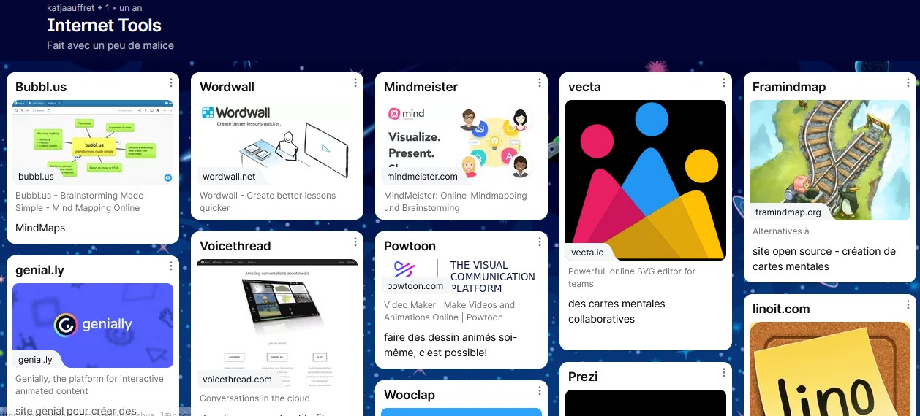

Illustration 2: Extract of the padlet with Internet tools
As the students all spent a lot of time on video conferencing tools during the pandemic, some students also had the opportunity to “meet” in a virtual building, rented by IMT Mines Albi and where the students could meet as avatars. The virtual building was programmed by the WBS group in Germany.
The students liked the meetings there a lot, but said that in the beginning of the GC program, they wanted to meet on video conferencing tools to see what their partner(s) looked like.
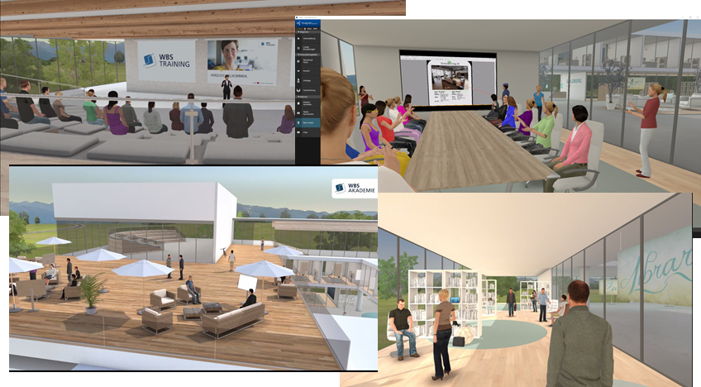

Illustration 3: WBS Learnspace 3D
We have been integrating students' e-communication program into their practical courses of English (other foreign languages that students learn) , in particular a course of Conversational English. At VolgaTech the topics of the latter correlate with the topics of the program. Through embedding preparation and participation in the program we promote cross-cultural awareness giving our students an authentic context in which to develop cross-cultural skills and to negotiate ideas in a foreign language.
To prepare your students for cross-cultural e-communication first you should introduce the course objectives and the purpose of the program and share all the documents designed for the actual cross-cultural exchange meeting. The participants do much better with the cultural communication opportunities when the questions and topics are clearly outlined beforehand and the students understand how these questions relate to the general course objectives. Be ready to explain what the students are responsible for before the interaction and afterwards. The students will be expected to participate in video conferencing sessions with engineering students from foreign universities. They also have to fill in a pre-survey questionnaire before and a post-survey questionnaire after their e-communication. As soon as they complete all the assignments of the virtual meetings they need to write a report on Global Conversations sessions corresponding to the chosen Round of the program (appendices 3.1-3.3, Volume 2).
The students should learn that once they know their partner’s email address (the list is compiled by the co-organizers and shared via Google Drive) they will be responsible for setting up a time to communicate for a 40- 60-minute conversation either 3 or 4 times depending on the program schedule that you choose (see appendices 2.1-2.3, Volume 2).
Ideally, we start the implementation phase (Stage 5) in the second part of our FL course for the students to be prepared for this interaction in advance during FL classes.
The first document that the students should fill in prior to their e-communication with an international partner is a pre-survey questionnaire that corresponds to the chosen round (see appendices 1.1-1.3). We would encourage you to discuss these questions to identify your students’ personal characteristics, their motivation and readiness to carry out cross-cultural communication. For them to think rationally about the potential difficulties that might come up during discussions with foreign partners and what personal and character traits might help to solve them. The other question that provokes useful debates is to think ahead of time about what other issues they would like to discuss with someone from another culture besides those on the list. (What is one topic that is NOT included in these conversations that you would like to discuss with someone from a different cultural background?) It helps your students to independently determine and compose their own, personally/professionally significant questions, as well as questions related to the solution of professional ethical dilemmas they are mostly interested in.
As it has already been mentioned in part 2 we primarily discuss and study all the specified conversation topics 1) Cultural Diversity and Stereotypes 2) Education Systems, Values in Education, and Professional core values 3) Professional ethical dilemmas 4) Growing social Issues in our FL classes to enlarge our targeted vocabulary. The choice of the targeted vocabulary depends on a foreign language you teach. In fact, you can start with some key terms of the program: e.g.: the definition of “cross-cultural”. According to the Merriam-Webster dictionary, cross-cultural means “dealing with or offering comparison between two or more different cultures or cultural areas.” This simple definition works as cross-cultural researchers study and compare cultures. Cross-cultural communications explore the different communication styles of cultural groups.
https://www.europeanmarketlink.com/2019/10/18/cross-cultural-intercultural-and-multicultural/
You might like to talk about cultural fears and biases ahead of time so you have some idea of where the students are and how many of them struggle with the issues of this kind. This kind of activity in the classroom will help students think critically about their own cultural bias and background. During their first video conferencing session they will analyse their own perceptions and stereotypes of other cultures being in direct communication with someone from another culture who may think differently about important social or moral issues and professional dilemmas.
The other activity is using a word cloud to kick off the discussion about stereotypes in class and during video conferencing session 1 (suggested by J.C. Dunderdale, IMT, Albi)

Illustration 4: Word-cloud from French students about Russia

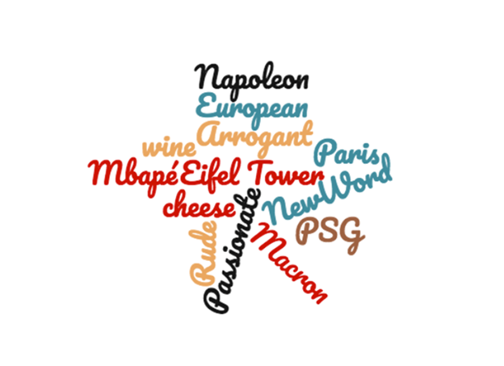Illustration 5: Word cloud from Russian students about France
We believe that it is essential to focus on students’ rules of professional cross-cultural e-communication developing them together with your students. You can use the following activity plan developed by T. Golikova, VolgaTech:

Template for the activity plan
Students’ rules of professional cross-cultural e-communication (speaking interaction)
1. Aim of the activity (including a statement from the framework) | Speaking B1 I can use a range of simple language to deal with formal and informal situations and suggest solutions. I can interact in a work-related conversation and participate in meetings about my work. I can ask questions to develop the topic of conversation.
2. Preparation | Before students develop a mutual set of rules in class relevant in professional cross-cultural e-communication, ask them to find factual information on the issue from outside sources. Ask your students to prepare their list of these rules based on their factual information via google drive. Ensure your students have different internet gadgets to use in class.
3. Set-up | The aim of this assignment is to develop students’ spoken interaction to collaborate with international co-workers for educational and professional purposes to enhance their job performance and career opportunities in future. Explain that in their future professional sphere students will collaborate in person/online with people from different cultures/countries using English/other foreign languages as a language of communication/ e-communication.
4. Activity description (in numbered points) | 1. Brainstorm ideas about the rules of e-communication conducting a debate/ a small talk etc.  2. Students work in micro groups: share their prepared information via Google Drive comparing common and specific rules in their set of rules they would like to include into their mutual set of rules for a micro- group.  3. Students listen to the spokesperson for each micro-group to opt for the common rules that resonate with them the most.
5. Plenary | 1.Ask the students to identify common rules which resonate with them the most (full group discussion).  2. Create a mutual document via google drive.  E.g. :  1. respect the right of other people to have a different opinion;  2. do not interrupt when others are speaking;  3. do not distract other listeners and do not hinder their responses;  4. maintain an atmosphere of trust to allow everybody to speak honestly and sincerely;  5. do not allow mockery or sarcastic comments.

6. Follow-up  (optional) | The students can also compare their rules and regulations for effective e-communication (spoken interaction) with the other engineering students/ students from other universities.
7. Variation  (optional) | Ensure your students have different internet gadgets to use in class.  You can ask students to prepare (surfing the internet) their factual information and their list of the rules of professional cross-cultural e-communication in class via google drive rather than doing it in advance at home.

Illustration 6 : Template for a lesson plan
Preparing your students for the program we also should develop their presentation skills that resonate with both e-communication and FL course objectives. We teach them useful phrases for their introduction; for the main parts, conclusion and for managing questions. It is also helpful to ask students to give their presentations (one per topic) in class for them to practice the target vocabulary and learn a topic better. It is especially essential for the students with a language barrier as it fosters their FL proficiency.
Ask your students to look through the assignment for each videoconferencing session and first to prepare and practice their answers during their FL classes trying to predict potential questions that may arise. During their first session they need to introduce themselves, their city, country and university. We ask our students to think critically while choosing the factual information that will attract their partner’s attention and will be definitely useful/memorable for him/her. Here are some slides that vividly demonstrate the presentations the students shared during their online interaction.
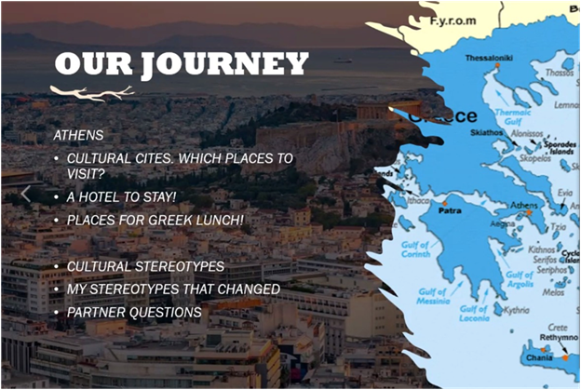Illustration 7: Student presentation

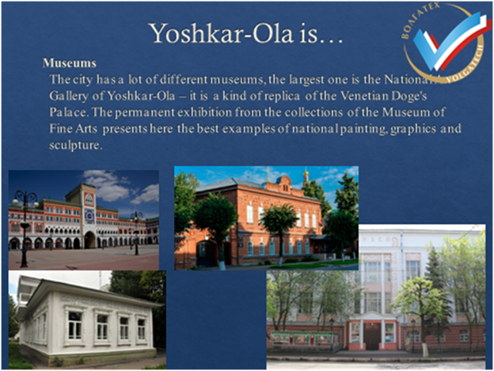Illustration 8: Student presentation
We also ask our students to prepare a talk introducing themselves, their university and faculty briefly for their first full group introductory meeting that the co-organizers arrange. Here are some photos from such introductory sessions (ref.https://www.volgatech.net/news/Novosti_obrazovaniya/408077/?sphrase_id=753243 (2019-2021)).

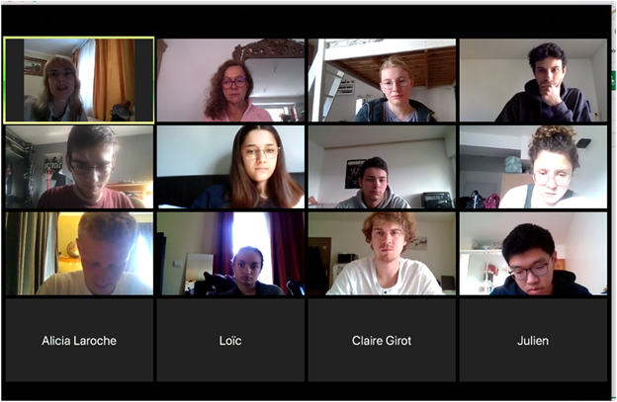Illustration 9: First videoconferencing sessions Volgatech, IMT Mines Albi
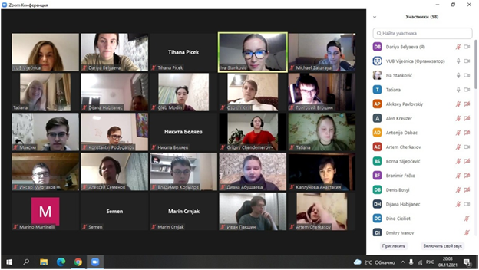

Illustration 10: Videoconferencing session Croatia - Russia

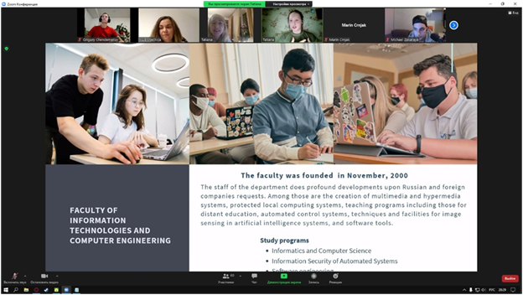Illustration 11: Presentation of VolgaTech, Russia, by Russian students

To prepare for video conferencing session 2 engineering students prepare information about their educational system, their university/ department and professional interests.

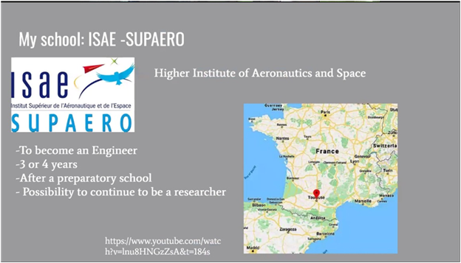Illustration 12: Presentation of Isae-Supaéro, France, by French students

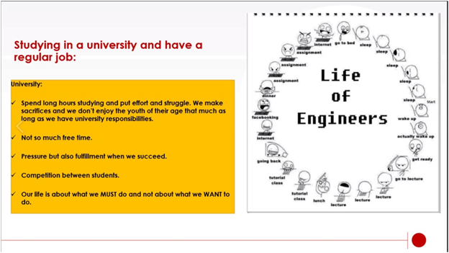Illustration 13: Students’ presentations about HE
To stimulate their comparison of different systems of education we ask them to read the following blog on Eastern versus Western cultural norms in education:
https://blog-thepensters-com.cdn.ampproject.org/v/s/blog.thepensters.com/west-east-education/amp/?amp_js_v=a6&amp_gsa=1&usqp=mq331AQFKAGwASA%3D#aoh=16032028716180&referrer=https%3A%2F%2Fwww.google.com&amp_tf=%D0%A1%20%D1%81%D0%B0%D0%B9%D1%82%D0%B0%20%251%24s&ampshare=https%3A%2F%2Fblog.thepensters.com%2Fwest-east-education%2F

and be ready to discuss if they have observed some of the characteristics in the article to be true in their experience with education in their home culture.
We also ponder over professional and personal values for the students first to identify them for themselves. Those aspects are closely connected with the topic about professional ethical dilemmas that we will address in detail in part 4. Later they share their set of values with their GC partners (e.g.: the screenshot below is from NTUA).

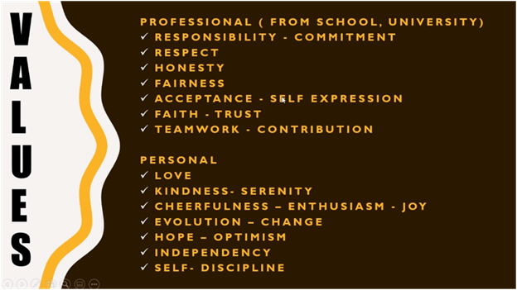Illustration 14: Students’ presentations about values
We should also note that we ask our students to take screenshots during their video conferencing sessions to keep a protocol of their interaction that will help them to write a detailed report. We never ask them to record their sessions purposefully as part of the assignment. In our experience, there is somewhat psychological pressure interfering with their conversations otherwise.
As you may already realise, if you choose Round 1of the GC topics (appendix 2.1, Volume 2) then your final topic for students to explore and speak on is Social Issues. Growing Global Concerns. It involves a serious conversation about the most pressing social problems in one's own country. The students study quite a lot of issues during their preparation and their final task is to choose one from the list: social welfare systems in your respective countries, gender issues, refugee crisis, euthanasia laws, bans against international adoption, sex trafficking, juvenile delinquents, drug abuse epidemic, terrorism, racial violence, inner-city poverty, environmental concerns, suicide rates, cybercrimes etc. Finally, they share their ideas about how the social issues could be addressed from their perspective. The comments their classmates share open their eyes to new thoughts and ideas on a chosen social problem. They need to exercise good judgement before they start solving professional ethical dilemmas.

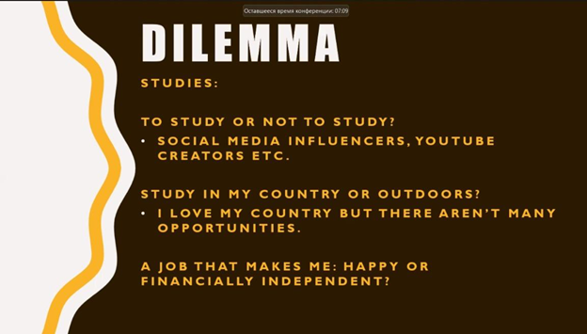Illustration 15: First dilemmas imagined by students
The students especially need to concentrate on the social issues in detail prior to their sessions with their foreign partners about the most pressing social problems in their country (see some of the examples below).

Illustration 16: social problems presented by students
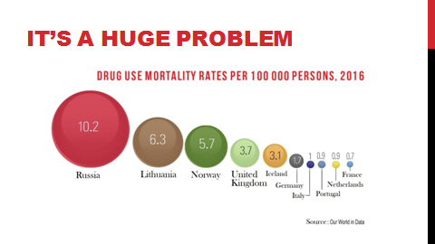

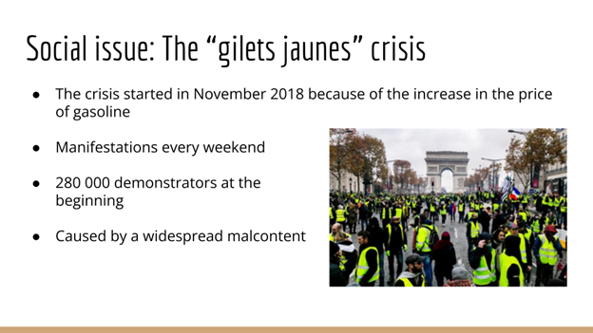

Illustration 17: Social issues in France presented by students
Illustration 18: Students’ presentations about social issues
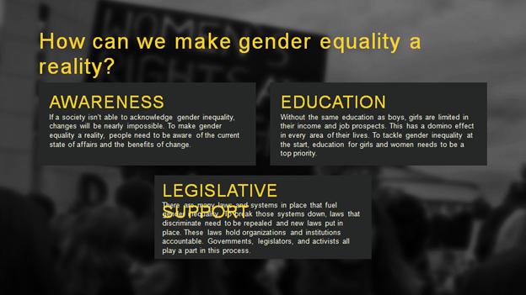
They need to learn how to select reliable resources to find factual information to prove their view as it is not just about FL skills but mostly about a knowledge-based approach that can be used in their scientific field as well. In fact, at VolgaTech first-year engineering students along with general engineering courses have their major ones. Hence in their FL classes they study and search for some specific materials and prepare pptx about their scientific interests or area of study. At some point you have to teach them how to ask a set of questions relevant to their prospective research/area of study to collect data during their GC video conferencing sessions if applicable.
It is important to emphasise that classroom discussion of the tasks allow the participants to prepare more thoroughly and contribute to more fluent FL communication.
As you may already have realised, we have altered the topics of the initial GC program Round 1 several times (K.Auffret and T. Golikova) to better adjust to the needs of the BADGE project. In particular the topic that deals with personal/ professional ethical dilemmas is connected with IO7 (b): Mobile App for Global Competence through a serious game. Especially helpful for students to understand the nature of cross-cultural conflict resolution was to examine and solve critical incidents that our colleagues have been collecting at KTH Royal Institute of Technology, Sweden. You can find all necessary resources:
- Catalogue of critical incidents
- Serious game about intercultural empathy with instructions and scripts
- And of course this e-guide Volume 1 with explanations and instructions and Volume 2 with the annexes here:
https://www.thebadgeproject.eu/io7-global-competence-through-it-and-serious-games/
Before we delve into the specificities of using professional ethical dilemmas in FL classes in part 4 we would like to highlight the importance of one of the assignments in the framework of the GC program namely a final detailed report that corresponds to the chosen round of the program (appendices 3.1-3.3, Volume 2). We believe that it enhances writing skills (A2 -B2 according to the GELS framework, https://www.thebadgeproject.eu/io3-e-communication-skills/ ). Each of the reports the students write are evaluated according to the content and factual information they provide as a sample of their reflection on the discussions with their cross-cultural partner. Any stylistic or grammar issues that are noted in the report does not result in any grade deduction; rather, we address them individually in private consultations during the final classes of the course. Nevertheless, it is useful to examine and analyse your students’ most common grammar/lexical/ stylistic issues to further hone their writing skills addressing those aspects in FL classes.

Part 4 Professional ethical dilemmas in FL classes
As professional ethical dilemmas are part of the GC sessions we recommend that you should introduce them prior to your students' cross-cultural communication with their international partners. We would like to share the teaching methods of using professional ethical dilemmas in FL classes that are part of a pedagogical technology of using professional ethical dilemmas developed by T. Golikova. It focuses both on linguistic skills and on personal, professional values education in foreign language classes. The application of this technology contributes to the formation of a competitive personality of a future engineer, motivated to learn a foreign language and master his/her professional and ethical values in the global digital society. This process is facilitated by the discussion of professional ethical dilemmas with foreign students, representatives of European technical universities within the integration of its online component. The technology of using professional ethical dilemmas for engineering students are implemented in the process of teaching English (any foreign language), are conducted in a FL and includes the following stages:

Stage 1 – preparation. The students consider the basic concepts: a dilemma, a professional ethical dilemma, principles of professional ethics based on universal norms of morality. They get acquainted with the methods of discussing dilemmas and a bank of professional ethical dilemmas.
Stage 2 – diagnostics. The teacher identifies the students’ levels of professional values development, reveals professional and ethical core values through classroom discussion.
Stage 3 – modelling. The teacher together with the students make a model of a competitive personality of a future IT engineer possessing professional and ethical norms applicable in a digitalized global environment and society integration.
Stage 4 – compiling professional ethical dilemmas. The students select professional ethical dilemmas for discussion by brainstorming ideas in micro-groups. The students develop scenarios of the selected dilemmas and analyse them from different points of view to solve them.
Stage 5 – interactive presentations of a professional ethical dilemma by the participants of a micro-group, according to the developed scenarios. Students choose a presentation program (PowerPoint/Powtoon/Canva, etc.) and, according to the dilemma discussion method, ask the group to solve their proposed professional ethical dilemma ( Examine an example of how to organise a dilemma discussion below).
Stage 6 – a discussion stage. A discussion of professional ethical dilemmas in micro-groups, representatives of each micro-group argue and give counter-arguments. (*the students solve professional ethical dilemmas with their international partners, if applicable).
Stage 7 – socio-moral reflection. Summarising the results of the discussion of the professional ethical dilemma, focusing on the possible options of action choices by the participants
Stage 8 – prognostic evaluation. Further work is based on the main linguistic difficulties and the formation of professional ethical values relevant to a particular group of students.
In this e-guidebook we share some of our activities. Each stage has more material that can realistically be handled in a timely and efficient manner thus each educator can substitute the activities that we recommend or use them selectively. In our experience you should start by identifying students’ core values both personal and professional as it correlates with the GC assignment and it enhances your students' speaking interaction.

Template for the activity plan
Students’ professional ethical values (speaking interaction)
1. Aim of the activity (including a statement from the framework) | Speaking B1 I can use a range of simple language to deal with formal and informal situations and suggest solutions. I can interact in a work-related conversation and participate in meetings about my work. I can ask questions to develop the topic of conversation.
2. Preparation | Before students develop a mutual set of professional ethical values in the classroom ask them to find factual information on the issue from outside sources. The required reading is in the course moodle e.g. The ethical conduct of all computing professionals https://ethics.acm.org/. Ask them to examine more sources on the matter including local documents if any. Ask your students to prepare their list of such values based on their factual information via google drive. Ensure your students have different internet gadgets to use in class.
3. Set-up | The aim of this assignment is to develop students’ spoken interaction to collaborate with international co-workers for educational and professional purposes to enhance their job performance and career opportunities in future. Explain that in their future professional sphere students will collaborate in person/online with people from different cultures/countries using English/other foreign languages as a language of communication/ e-communication solving different professional ethical issues.
4. Activity description (in numbered points) | 1. Brainstorm ideas about professional ethical values the students can relate to.  2. Students work in micro groups: share their prepared information via Google drive comparing common and specific in their set of values they would like to include into their mutual document for a micro- group.  3. Students listen to the spokesperson for each micro-group to opt for the common set of values that resonate with them the most.
5. Plenary | 1.Ask the students to identify common values which resonate with them the most (full group discussion).  2. Create a mutual document via google drive.  E.g. :  “Our common professional ethical values: diligence honestly, integrity, responsibility, good motivation, adaptivity, ethics, loyalty, trust, inner peace, safety.”  3. Elicit their comments on each value.
6. Follow-up  (optional) | During their cross- cultural e-communication the students can also compare their set of values with the other engineering students/ students from other universities as part of their assignment.
7. Variation  (optional) | Ensure your students have different internet gadgets to use in class.  You can ask students to prepare (surf the internet) their factual information and their list of professionals in class via google drive rather than doing it in advance at home.

Illustration 19: Template for the activity plan
This type of activity is also effective in terms of preparing students for a similar conversation with foreign engineering students during their videoconferencing session 2 when they compare their personal/professional values. Quite a lot of students figured out that they have the same set of values. We can quote some of our students: “…Our partners share our professional values. For example, they want to go to work as early as possible to gain experience. It is especially important to emphasise that family values are their priority.”
“…We think that the main value in our professional sphere is striving for development and improvement. Our partners believe that the main thing is respect. They say that you always need to listen to a different side of the story, and then you tell yours to find a compromise and the best solution. ”
For the purpose of this e-guidebook, we will concentrate on stages 4, 5, 6 and 7 namely on the methods of using professional ethical dilemmas in FL classes.
At VolgaTech we mainly explore professional ethical dilemmas stimulating the development of the following values: justice, responsibility, respect, integrity. To solve dilemmas, students need to develop FL speech skills relevant in cross-cultural e-communication (B1, B2)
(https://www.thebadgeproject.eu/io3-e-communication-skills/) to react to remarks and questions. While discussing issues which they consider to be important, the language barrier disappears, and speaking skills develop. Students improve their writing by preparing the dilemmas and recording the statements of the members of the micro-group while enriching their English vocabulary. By sharing their opinions on the dilemma, answering questions, and role-playing a tough moral situation, students develop their critical thinking and figure out universal values that transcend culture to stimulate their problem-solving process (Golikova, T. (2016)).
The teacher starts by telling the students that in their future professional sphere they will collaborate in person/online with people from different cultures/countries using English or other FL as a language of communication. While dealing with different people they will learn how to cope with professional/ cultural/personal issues solving everyday problems including professional ethical issues. The teacher should be a facilitator of authentic student reflection and reasoning and not impose choices or conclusions on the students.
First you brainstorm ideas about personal/professional dilemmas your students have faced in real life/ read about. Students work in micro groups. They can also choose some of the professional ethical dilemmas collected by VolgaTech students:
https://drive.google.com/file/d/1P3z6vhkTsvAAS1SDGa3tgLAvjFuRqUjL/view?usp=sharing or
critical incidents on cross-cultural issues that our colleagues have been collecting at KTH Royal Institute of Technology, Sweden:
https://www.thebadgeproject.eu/io7-global-competence-through-it-and-serious-games/
Ask the students to share which one resonates with them the most. Later as part of their assignment after their video conferencing session with their international partners for the classroom discussion they need to:
- Describe a dilemma that you/ your international partners have faced in real life/ read about.
- Define the dilemmas you chose to discuss with your GC partner.
- Conclude with a description of your partner’s solutions to the dilemma/ dilemmas discussed as compared with yours.
*The students can answer the above mentioned questions in writing. If that is the case then it will develop writing B1, B2.
*The teacher can incorporate all the dilemmas the students would like to discuss (both from the given list, students’ own dilemmas) later during their FL classes.
Examine the example below of how to apply the dilemma discussion method developed by T. Golikova (Golikova, T. (2012). Before students learn how to organise it on their own the teacher gives an example of a professional ethical dilemma. E.g.:
Professional ethical dilemma: “What are you willing to do to get your dream job?”.
Imagine the following situation. You are working for an IT company. The head of your department tells you about a vacant position for you to be promoted. The position you have dreamt of. But he has one more candidate and he suggests that you both should write a program and he will choose the best programmer to be promoted. Your rival is objectively very good at what he does. And you have doubts if your program will be better but you know some information (something related to an ethical concern or just an embarrassing professional mistake) about your rival that will almost for sure ruin his chance of getting this position. What will you do?
1. Will you inform your boss about this confidential issue to win at all costs?
2. You will not use this information as you want to win on the professional level.
3. Your alternative solution
- The students are asked about the values that are at stake in the dilemma (students’ answers). This dilemma stimulates the formation of the following values: justice, responsibility, professional competence, confidentiality.
The teacher assists the student (s) responsible for preparing a dilemma by editing its contents linguistically and in terms of its ethical component if need be.
I. Preparation of a dilemma. The students create their own dilemma working individually or in a micro-group or as it is in the given situation they can use one of the dilemmas suggested by the teacher. A student /a micro-group who is responsible for the dilemma discussion compiles the contents of probe questions for the discussion and tries to figure out solutions to a dilemma identifying professional ethical ones.
II Presentation of a dilemma. The students prepare an interactive presentation either individually or in a micro-group. In our case Diana Abushaeva, a VolgaTech IT student developed it. The students may either solve this dilemma autonomously online following the link with the PPT (view one of the slides below). For the purpose of the e-guidebook, we share how to discuss professional ethical dilemmas in your class whether in person or via hybrid learning.
III Clarification. The questions are asked to make sure that the students understand the dilemma as English (other FL) is not their native language: “You’ve heard the dilemma. Now, answer the following set of questions.”
1. What is at stake here?
2. How would you behave? Defend your answers. You will examine the problem in detail in micro-groups.
IV. Primary decision-making. The students vote and form micro-groups according to the chosen option.
V. Micro-group discussion. The students reason out their solutions in micro-groups, aided by the use of the brainstorming method. During the discussion, the students listen to everybody’s reasoning on the chosen option, weighing all pros and cons, and write down the argued rationale of their decision. Next, a spokesperson for the group gives an oral presentation in defence of the group's common opinion. The students listen to an oral presentation from each group's spokesperson justifying their group's choice. Each spokesperson is asked additional questions, and is presented with counter arguments. In this discussion any member of the micro-group can take an active part. Here are examples of alternative solutions provided by the student who organized this dilemma discussion. The students have a right to dramatically alter the given initial choices:
You will inform your boss about this confidential issue. |  |  |  | You will not use this information as you want to win on the professional level.
Tell the rival, that you will inform your boss |  | You won't tell the rival, that you will inform your boss |  | Talk to your rival about the information you have. |  | You won't tell the rival anything
You will make the information publicly available  1 | You won’t make the information publicly available  2 | You will make the information publicly available  3 | You won’t make the information publicly available  4 | You will make the information publicly available  5 | You won’t make the information publicly available  6 | You will make the information publicly available incognito  7 | You won’t make the information publicly available  8

Illustration 20: Dealing with a dilemma
VI. Full group discussion. At this stage, the students are asked to answer additional questions to demonstrate the multifaceted nature of the dilemma and the choice of questions depends on the micro-groups’ or their individual choices. The teacher asks the students to think about possible consequences in each case mentioned in the table above, stimulating their critical thinking and developing professional ethical values. In the framework of the BADGE project, VolgaTech students were involved in writing scripts for a mobile application with a serious game, simulating real work life situations in intercultural environments on the basis of their dilemma discussion. This very dilemma discussion shows the outcomes of the process most vividly:
1. You inform your boss about this confidential issue. You also tell your rival about it. Additionally, you make the information publicly available.
Possible consequences:
· Your colleague is fired in disgrace.
He is fired because of a mistake; you are fired for denouncing.
· Your rival is forgiven for the mistake, and you are fired for denouncing.
· You are fired for spreading rumours.
· None of you is fired, but both of you are deemed unworthy of the position.
· The competition is held and you lose. You don’t get your dream job. Your relationship with your colleague is ruined. Your colleagues’ attitude changes drastically, because of your gossip.
· The competition is held and you win. You get your dream job, but you have a bad relationship with your colleagues.
2. You inform your boss about this confidential issue. You also tell your rival about it. You don’t make the information publicly available.
Possible consequences:
· Your colleague is fired in disgrace.
You are both fired. He is fired because of a mistake; you are fired for denouncing.
Your rival is forgiven for the mistake, and you are fired for denouncing.
None of you is fired, but both of you are deemed unworthy of the position.
The competition is held and you lose. You don’t get your dream job. Your relationship with your colleague is ruined. Your colleagues’ attitude changes drastically, because of your gossip.
· The competition is held and you win. You get your dream job. Your relationship with your colleague is ruined
3. You inform your boss about this confidential issue. You don't tell your opponent about it. Additionally, you make the information publicly available.
Possible consequences:
· Your colleague is fired in disgrace.
· You are both fired. He is fired because of a mistake; you are fired for denouncing.
· Your rival is forgiven for the mistake, and you are fired for denouncing.
· You are fired for gossiping.
· None of you is fired, but both of you are deemed unworthy of the position.
· The competition is held and you lose. You don’t get your dream job. Your relationship with your colleague is ruined. Your colleagues’ attitude changes drastically, because of your gossip.
· The competition is held and you win. You get your dream job!
· Your opponent has problems with his/her colleagues and he/she does not understand the reasons for it.

4. You inform your boss about this confidential issue. You don't tell your opponent about it. You don’t make the information publicly available.
Possible consequences:
· Your colleague is fired in disgrace.
· You are both fired. He is fired because of a mistake; you are fired for denouncing.
· Your rival is forgiven for the mistake, and you are fired for denouncing.
· None of you is fired, but both of you are deemed unworthy of the position.
· The competition is held and you lose. You don’t get your dream job.
· The competition is held and you win. You get your dream job! The boss treats your rival badly.
5. You don't tell the boss anything. You talk about your current situation with your opponent. Additionally, you make the information publicly available.
Possible consequences:
· Your rival decides to confess to the boss. He/she is fired.
· Your rival decides to confess to the boss. It does not affect anything; the competition will be held. As a result of your gossip your opponent takes offence.
· The boss finds out about your rival’s mistake as a result of your gossip. He/she is fired. You are fired for not reporting about it.
· The boss finds out about your rival’s mistake as a result of your gossip. He/she is fired. You get your dream job.
·
6. You don't tell the boss anything. But you have a talk with your rival about this confidential issue.
Possible consequences:
· Your opponent decides to confess his/her mistake and tell the boss about it. He/she is fired.
· Your opponent decides to confess his/her mistake and tell the boss about it. Eventually it does not affect anything, the competition is held.
· You lose the competition and after that you decide to tell your boss about your opponent's confidential issue.
· You lose the competition. You decide to use this information in the future
· The competition is held. You win!
· You win the competition. You also tell your boss about your opponent's confidential issue. Your rival is fired
7. You don't tell the boss anything. You also don’t tell a colleague anything. You spread rumours in the workplace.
Possible consequences:
· The boss finds out about your rival’s mistake as a result of your gossip. He/she is fired. You get your dream job
§ The boss finds out about your rival’s mistake as a result of your gossip. The competition will be held. Your rival has problems with his/her colleagues and he/she does not understand the reasons for it.

· Your opponent wins the competition, but his reputation is significantly damaged.
· Your opponent loses the competition. His reputation is significantly damaged.
8. You do not tell anybody anything.
Possible consequences:
· A fair competition is held. You win and you are proud to have won fair and square.
· A fair competition is held and you lose.
· You decide to tell everything after the competition.
· The boss finds out about your opponent's confidential issue. He/she is fired.
· The boss finds out about your opponent's confidential issue. He is fired. They also find out that you are aware of this confidential issue. You are fired for not reporting about it.
VII Final decision-making. The students reflect on their initial and alternative choices on the dilemma and make a final decision. Here are some common solutions from 5 micro-groups (VolgaTech students):
1. If we are on friendly terms, we will definitely not tell the boss. If the team has a good relationship with the boss, then the situation with a colleague's mistake will eventually be resolved peacefully. We don’t want to ruin our relationship in the team. Or, if we are not on friendly terms with this rival, then we will have a talk with him directly. Anyway, we will not tell the boss.
2. We choose the second option (not to tell the boss). We think that everyone has the right to make a mistake. It is not our problem and we do not have to deal with it. Anyway, sometime later this information will be disclosed.
3. We will choose not to tell the boss and colleagues anything. We will have a talk directly with the rival. Since his/her act or mistake may turn out to be critical for the company in the future. Perhaps after our conversation, he / she will decide to report everything to the authorities. This is not blackmail by any means. It will be honest and fair both personally and professionally.
4. We have decided not to tell the boss anything, as the competition is primarily about professional skills, and other factors shouldn't affect it. We will not tell our opponent anything either as it will break our relations with that person. Finally, we have decided not to tell other people anything, as it isn't their business at all.
5. We wouldn't tell the boss, because it doesn't matter who actually made that mistake. Moreover, what matters now is how to fix it.

VIII. Socio-moral guided reflection. Only at the end of this discussion the teacher should add his/her moral message to give them food for thought, presenting an overview of their investigation: “We have discussed a thorny dilemma connected with your future profession. In the situation we have described and pondered, the majority of you believe that this competition is primarily about professional skills, and other factors shouldn't interfere with it. You will choose not to tell the boss and colleagues anything, but to have a talk directly with the opponent. You argue that his/her act or mistake may turn out to be critical for the company in the future. You hope that afterwards she / he will decide to disclose this confidential information. You also believe that it will be honest and fair for him both personally and professionally. After all, what matters now is how to fix the rival’s mistake. It is critically important to be just and be responsible for your personal/professional decisions including mistakes.
We have a firm conviction that it is crucial for students to learn how to solve professional dilemmas ethically and treat their prospective colleagues the way they want to be treated themselves. VolgaTech students note that professional ethical dilemmas discussion makes them reflect on their committed action and its further consequences.

Part 5 Review of the findings and students’ feedback
We have been implementing this program for VolaTech, IMT, BUAS and NTUA students for three years. Its overall effectiveness is proven by the students' feedback, reports and post-surveys results.
For FL teachers’ protocol it is useful to compare the final results with some of their students' expectations from their pre-surveys. We ask our students what they hope to gain from the Global Conversations talks with their partner?
E.g.:
I hope to meet new people, to practice my language skills, broaden my horizons, and learn more about other cultures.
Cross- cultural experience, new acquaintances, new knowledge of a new country, it’s traditions and customs
new experience and knowledge about other country and culture
I want to improve my communication skills.
I believe that kind of communication experience plays to my strengths as a flexible and cooperative person. I'm willing to improve my skills for my future career.
I am always open to new experiences in cross-cultural communication.
I'm sure it will be a great experience in cross-cultural communication
To get an intercultural experience from people of other cultures
English practice; understanding of people from other countries, their cultural peculiarities and their vision of life.
I would like to find out more about the culture and life today in the countries of my partners. I am eager to see if we look at some points differently, if our views depend on the generation. Moreover, it is a great chance to tell them more about Russia, to practice English and make new friends.
In their pre-survey questionnaires the students are asked ahead of time to ponder over what communication difficulties might come up during their discussions with a Global Conversations partner and to evaluate what personality or character traits might help them overcome these difficulties?
E.g.:
I think I need to be more confident, listen carefully to my interlocutors, and not be afraid to express my opinions and emotions.
Communicative skills
open-mindedness and tolerance
Opposing expectations; different values and ideas
I suppose that my open-minded character will help me to overcome any difficulties.
Tolerance and outgoing
Patience.
I'm responsible, easy-going and polite.
I am rather outgoing and open for new people and interesting conversations
Patience and open-mindedness, ability to think critically
Empathy, humour, tolerance, patience, optimism
In the framework of the program the students are encouraged to additionally discuss other issues that they can relate to personally/ professionally. We stimulate them to analyse what is one topic that is NOT included in these conversations that they would like to discuss with someone from a different cultural background:
Personal issues, such as likes and dislikes. Travelling experience
Political Correctness
The problem of finding compromises working with people from different cultures.
Traditions and customs in daily life
Job opportunity or collaboration there
I think these topics] cover all the questions I'd like to find answers for.
The opportunity to get a job in another country if you are a foreigner.
I think that all the interesting topics are included to the list above
People’s ideas of a perfect family. Everyday routine in the places they are living, their hobbies and interests. What they like and don’t like about their countries.
Ecological situation (recycling, fast fashion, ways of improving the situation)
Overall, the students' feedback is positive and compelling:
This course is the best thing I've ever participated in.
I liked it and would like to participate in more projects like this.
It was fun, nice, I got a chance to speak in English but it was hard to get up from the bed in the morning.
It is an experience. I don't know if it is the best format for me personally, but it has positive sides, getting to know people from other countries, talking to them, seeing their perspective... It is educational and beneficial.
Everything was great for me, this is my first time talking to students from another country in English. So this is really a new experience for me and I learned something new about the topics that were given to us. At first, I didn't think I would be able to get along with students from another country because I thought I wasn't that good at English but in the end, it turned out to be quite good which actually makes me happy.
Interesting experience, I would do it again
I thought it was a creative way to expand one's views regarding stereotypes and social problems
7/10. A lot of awkward silences because of technical limitations, overall interesting topics were discussed. It was interesting to hear different takes on things from students from VolgaTech.
Great idea for those who want to improve their language.
To quote some of the students (Round 6):
“By communicating with guys from other countries, we can expand our understanding of the problems in the world and how to solve them, taking into account the views of all concerned parties (since we are representatives of other cultures, therefore we have “points of contact” and sharp divisions).
“In conclusion, for ourselves, we decided that social problems for the most part do not depend on culture and country. They are all similar due to the human factor. Our Croatian partners helped us confirm this. After all, no one likes that someone imposes their side, proves their innocence and simply shows their lack of culture. But it is worth noting how rich is the culture of Croatia, which certainly needs to be protected from social problems.”
“This course proved to be useful for me, because this course showed that I needed to improve my English level.”
“Global Conversation makes it clear that young guys are alike and this makes it possible to remove differences that interfere.”
“It was a very unusual experience for me, interesting, but really hard (I had to overcome my shyness, fears). This course helped me to improve my English skills, to meet new interesting people, and to learn more about my group mates. So, I'm glad I participated in this project.”

Furthemore, the diagrams below demonstrate some post-survey answers:
VolgaTech Fall 2021:

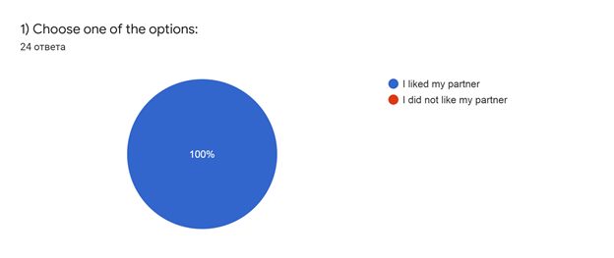Illustration 21: Students’ feedback
Out of 31 Croatian IT students (Fall 2021) 90% liked the experience.

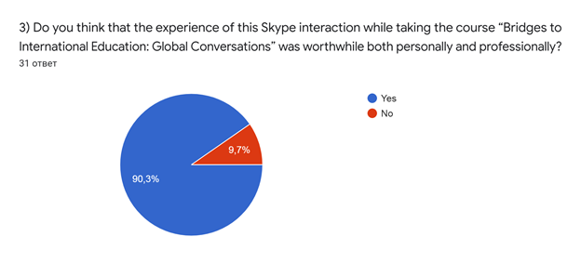Illustration 22: Students’ feedback

Reflecting on our students' reports we figured out that this experience motivates them to master a foreign language and improves their FL skills.
E.g. VolgaTech students Round 2 (Spring 2020)

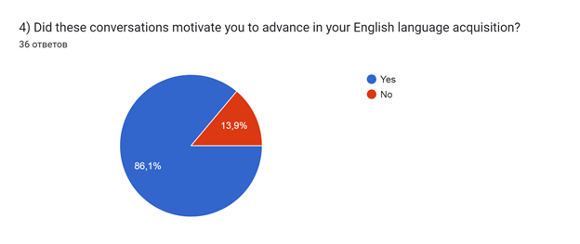Illustration 23: Students’ feedback

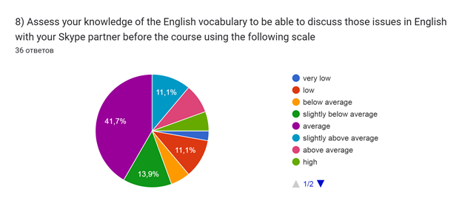Illustration 24: Students’ feedback

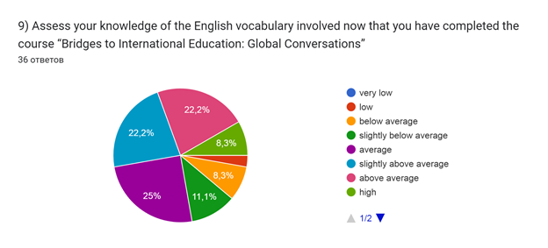

Illustration 25: Students’ feedback

On balance, describing our findings, we can also prove that the students need and like discussing professional ethical dilemmas that simulate prospective professional issues and their conflict resolution. Quite a lot of students referred to this topic as their favourite one “most interesting and vital”:
My favourite topic was social issues and professional dilemmas, because I was curious about my partners’ opinions
My favourite topic was dilemmas that we chose, because we had more freedom.
My favourite topic was social issues/professional dilemmas. These discussions were my favourite because I learned a lot about what my partners think of certain topics and it gave me an interesting perspective on things we discussed.
The topic of professional dilemmas and social issues seemed to be the most compelling one to discuss.
Professional dilemmas were my favourite topic to discuss because I am very connected to the internet and when I was reading dilemmas given to us from two links I was like yea, that happens. I can see how it affects those people, how to change something etc.
My favourite topic was social issues and professional dilemmas. Because we can brainstorm our ideas and thoughts about life situations and professional & social issues.
My favourite topic was dilemmas, as it was interesting to find out what they have in their hearts.
I liked dilemmas. I'm interested in thinking about solutions
Finally, we would like to share more screenshots of lively videoconferencing sessions from different cohorts below.

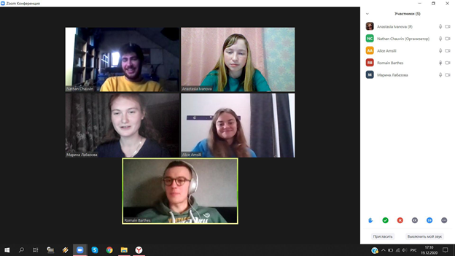 Illustration 26: Students’ micro group video conferences (IMT Mines Albi, INSA Toulouse and VolgaTech students (micro-groups and individual sessions) 2019-2020
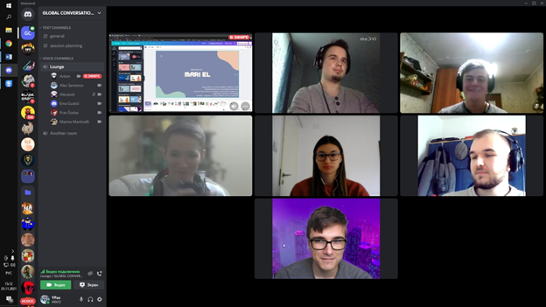

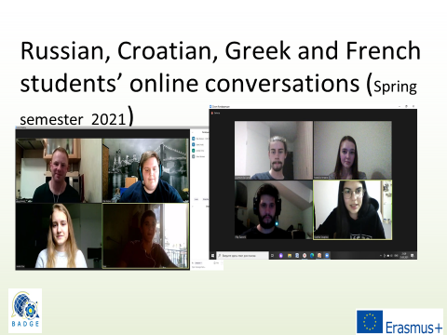
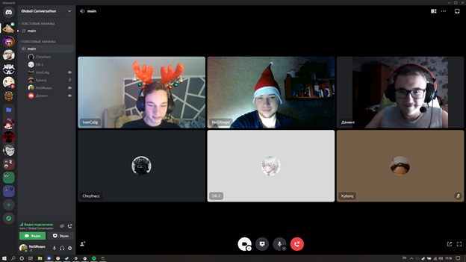Illustration 27: Students’ micro group video conferences (Russia and Croatia)

Illustration 28: Students’ micro group video conferences (Russia, France, Greece and Croatia)

Conclusion

We would like to conclude this e-guidebook by arguing that the proposed cross-cultural e-communication joint program aimed at developing global competence and cross-cultural asynchronous /synchronous e-communication can be applied as an integral part of any conversational FL course for prospective engineers. As it has already been indicated, in the framework of the BADGE project (2019-2021) more than 220 engineering students from VolgaTech (Russia), IMT Mines Albi University (France), Belovar University of Applied Sciences (Croatia) and National Technical University of Athens (Greece) have successfully participated in this international partnership program.
We believe that the given structure of the program, the factors and barriers that influence the program’s effectiveness as well as a set of recommendations for in class preparation including specific activities will be fruitfully explored by our colleagues willing to organise a similar international partnership for their students. We would like to highlight the importance of developing students’ readiness for cross-cultural e-communication in advance of meeting with their international partners who are also learning to master their e-communication skills during FL classes in person/online or via hybrid learning. To implement the program, you can use all the materials that correspond to the chosen Rounds 1,2 or 3 namely pre-post- surveys, the topics of virtual meetings (Cultural Differences and Stereotypes, Educational Systems, Professional and Personal Values, Professional Ethical Dilemmas, Growing Social Problems) with their assignments and instructions for writing a report on Global Conversations video conferencing sessions (see the appendices).
In addition, teaching methods of using professional ethical dilemmas that we address in the e-guidebook might prove an important area for integrating professional values discussion into FL classes. We also encourage FL teachers to use our bank of professional ethical dilemmas as well as our serious game (https://www.thebadgeproject.eu/io7-global-competence-through-it-and-serious-games/) These tools will train students how to discuss and resolve professional dilemmas ethically while upgrading their FL and intercultural skills. Engineering students are motivated to recognize situa­tions where it is crucial to make a professional choic­e and find solutions to hypothetical dilemmas. The conversations that are prompted by these dilemmas provide students with the opportunity to make conscious, ethical de­cisions, and weigh the consequen­ces for these choices in academic, professional, and personal spheres.
At the same time students are developing their critical thinking as they reflect on their choices and engage in cross-cultural interaction. We ask them in their final detailed report to conclude with a description of how their exchange of views on shared understanding of values could play a role in thinking about solutions to social and professional issues. We view it as a key point of the program for the students to learn that despite the differences they may encounter in their cross-cultural partner, they still share a lot. Our students have stated in their reports that shared values can play a huge role in solving social problems as there are numerous examples from the past when peoples overcame huge problems mutually that an individual could have never done. They note that it helps to understand the causal relationship of actions globally. The design of the program helps to expand their understanding of the problems in the world and how to solve them, taking into account the views of all the members, and ensuring that all the sides are interested in following this common decision.
The other benefit is that the participants of the program learn to recognise their cultural biases, learn to respect each other and tolerate differences while discussing sensitive issues considering the views of all concerned parties. The students begin to appreciate their own culture and become aware of the values of other countries. The students recognize that they live in a new global time. They have many opportunities “..to explore this world as early as possible, in order to subsequently move on to their future profession. Those opportunities work now and solve many problems in terms of mutual understanding among people.”
Moreover, the program provides an opportunity for each student to become an active participant in their own educational process. It stimulates and motivates them to master e-communication in English (or any FL) as a means of creative self-development aimed at educating global engineers, competitive professionals. It also trains them to solve problems of interpersonal and intercultural interaction, including in the field of professional activity, which is critical for the current international cooperation in the global digital working environment.

Acknowledgements
Jamie Rinder
Lecturer in English
KTH Language and Communication, Sweden
Department of Learning in Engineering Sciences, School of Industrial Engineering and Management
Teresa Sweeney Geslin
Associate professor, Université de Lorraine, France
Goni Togia
Lecturer in English, NTUA, Greece
Ivana Jurcovic
Lecturer in English, Head of the International Relations Office, Bjelovar University, Croatia

References
Source : OECD: https://www.oecd.org/pisa/innovation/global-competence/
Cunningham, A., & Golikova, T. (2022). TESOL Professional Development through Global Conversations Partnerships. In Advocacy for Social and Linguistic Justice in TESOL (pp. 195-208). Routledge
Golikova, T.V. (2016). Using moral dilemmas and participating in Mari-American online courses in English classes to form the moral and civic qualities of future teachers/ T.V. Golikova//Reconsidering the Practice of CLIL and ELT. Narva College of the University of Tartu. (pp. 99-110) (ISBN 978-9985-4-0967-1)
Golikova, T.V. 2012. Socio-moral dilemmas as a means of embedding character education in English lessons. In European Science and Technology: materials of the III international research and practice conference: Vol. II. (pp.348-352). Munich, Germany: publishing

